IJASTEMS Title font size 24 and times new roman

Authors font size 11 and time newroman,italic,bold

Abstract—(font 9,and italic,bold)The goal of the Ship Data Network based on Gigabit ethernet technologies is to provide a broadband infrastructure as naval ships for convergence of voice, data and video applications. The critical data or voice or video from a single source equipment is to be delivered to the multiple equipment. Unicast of data or voice or video will consume a lot of bandwidth of network. So, a multicast philosophy and design that limits the bandwidth of the network is applied for the SDN. Opnet modeler simulator, simulates the Multicast of data or voice or video application for SDN topology with QOS limit.

Index Terms—Ship Data Network, Opnet ,QOS

I.Introduction

(content should font size 10 and time newroman)
Many distributed real-time applications, such as audio- and video-conferencing, collaborative environments and distributed interactive simulation require simultaneous communication between groups of computers with quality of service guarantee; these applications involve a source in sending messages to a selected group of receptors. Classic unicast and broadcast network communication is not optimal; therefore,[1] Deering proposed a technique called IP multicast routing for one-to-multiple and multiple to multiple communication, which entrusts the task of data duplication to the network applications can send one copy of each packet and address it to the group of involved computers. The network takes care of message duplication to the receivers of the group
.
Multicast IP is a bandwidth conserving technology that reduces traffic in the network. Protocol Independent Multicast (PIM)is a family of routing protocols that form multicast trees to forward traffic from multicast sources to subnets.PIM relies on the unicast routing tables created by any of several unicast routing protocols to identify the path back to a multicast source (reverse path forwarding, or RPF)[2]. With this information, PIM sets up the distribution tree for the multicast traffic. The PIM-SM protocols on the switch enable and control multicast traffic routing. PIM-SM is used to reduce the effect of multicast traffic flows in network areas because,it does not automatically flood traffic, it is a logical choice in lower bandwidth situations.[3] PIM-SM supports multicast groups spread out across large areas of a company or the Internet. Unlike dense-mode protocols, such as DVMRP, which initially flood multicast traffic to all routers over an entire internetwork.
PIM-SM is independent of a specific unicast routing protocol, but it does require the presence of a unicast routing protocol. PIM-SM uses the information from the unicast routing table to create and maintain multicast trees that enable PIM-enabled routers to communicate. Each PIM-SM domain requires the following routers Designated router (DR), Rendezvous pointrouter ,Bootstrap router (BSR). Although a PIM-SM domain can use only one active RP router and one active BSR, we can configure additional routers as a candidate RP (C-RP) router and as a candidate BSR (C-BSR). Candidate routers provide backup protection in case the primary RP router or BSR fails[4].
The DR is the router with the highest IP address on a LAN which sends register messages , join and prune messages to the RP router on behalf of directly connected source receiver respectively and maintains information about the status of the active RP router. PIM-SM builds a shared multicast distribution tree within each domain, and the RP router is at the root of this shared tree. RP must be as close to the source as possible. Only one active RP and BSR router exists for a multicast group. Sources use the RP to identify themselves to other routers on the network. The RP registers a source that wants to announce itself and send data to group members, joins a receiver that wants to receive data for the group and, forwards data to group. The BSR receives RP router advertisement messages from the candidate RPs and adds the RP router with its group prefix to the RP set.The BSR periodically sends bootstrap messages containing the complete RP set to all routers in the domain. The BSR ensures that all PIM-SM routers send join/prune and register packets.
In this paper we will describe our simulation results of multicasting for SDN network by using Opnet simulator . This paper is organized as follows: The second section describes literature survey of PIM-SM multicasting. The third section describes the architecture of SDN.The fourth section describes the simulation results and the fifth section describes the conclusion.
II. LITERATURE SURVEY

- VNS-RP algorithm for RP selection in multicast routing protocol PIM-SM

Baddi et al.[5] proposed a multicast RP selection algorithm based on VNS search. This algorithm selects the RP router with systematic change of arbitrarily chosen neighborhoods by considering both cost and delay functions. They proposed using a shared tree (ST). This kind of tree provides efficient management of multicast path in changing group memberships, scalability and performance. The main problem concerning the construction of a shared tree is to determine the best position of the root. Selection of the core (in CBT protocol) or Rendezvous Point RP (in PIM-SM protocol) affects directly both structure of multicast tree and routing scheme performances of multicast session accordingly.

- Minimizing Cost and Delay in a Shared multicast tree

Mohammed V[6] proposed that a multicast node among current tree nodes is suitably assigned to each incoming user. Such a node is selected in a fashion that tree cost and the maximum end-to-end delay on the tree are jointly minimized.

- Parallel GRASP Algorithm with Delay and Delay variation for RP selection in PIM-SM multicast routing

Youssef Baddi et al.[7] proposed using a Shared Rendezvous Point Tree SRPT to forward multicast packets. Multicast router in the network as root; this problem is called RP selection. This problem influences the multicast routing tree structure, and therefore influences performances of the multicast session and multicast routing scheme. Determination of a best RP position is an NP complete problem.They proposed a new RP selection algorithm based on Parallel GRAS Procedure. 2DV-PGRASP-RP selects RP by considering cost, delay and delay variation functions and can be easily integrated to bootstrap RP protocol used by PIM-SM.

- Fault Oriented Test Generation for Multicast Routing Protocol Design

Ahmed Helmy et al.[8] proposed new algorithm for automatic test generation for multicast routing.They used the forward and backward search techniques to generate the test.

III. PROPOSED METHOD

The Ship Data Network (SDN) is intended to provide a single broadband network for voice traffic, real time video and real-time mission critical data communication onboard Naval Ships. SDN inter connects Ships Combat System consisting of Advanced CCS for external communication and CMS for Combat Management system.SDN will also capture and process the discrete, synchro, analog and digital information from certain designated equipment on the ship and send the processed information in the appropriate format to designated systems. SDN will provide Health monitoring of the overall network and will also provide time synchronization and storage of important network parameters.
The scope includes supply of distribution and access switches and other network related services for the systems like ACCS and CMS.Resolving of issues related to provisioning of Virtual LANs (VLANs) requirements for ACCS and CMS. IP network based systems / equipment having an Ethernet
Interface and which require connectivity on SDN will be connected through access switches to the dual redundant core switches.
A three layer distributed architecture has been proposed for SDN. The three layers are categorized as Core Layer, Distribution Layer and Access Layer. The Core layer having two Core Switches is configured as the nucleus of the network and is intended to provide means for information exchange between various systems like ACCS and CMS. The Access layer having a myriad of Ethernet Edge Switches is the outermost layer and is intended to provide connectivity to the end equipment of all systems like ACCS and CMS. The Distribution layer having two dedicated distribution switches for each system (ACCS and CMS) is positioned between the Core layer and the Access Layer providing connectivity Between two layers.
A .CORE LAYER

The core layer is the high speed backbone of SDN and facilitates efficient transfer of data between interconnected distribution layers namely ACCS and CMS. The core layer also provides central services like time synchronization, storage and Network health management. The core layer will consist of two numbers of high end Ethernet routing switches (Core switch) connected through dual redundant IST (Inter Switch Trunk). This layer is also populated with Multi Protocol Input Output Units,NHMS (Network Health Monitoring System), Storage Servers and NTP/PTP Servers. Servers for centralized network related services[9]. The core switch will have a minimum of 30% vacant slots in the chassis for future growth and a minimum of 30% vacant ports for scalability.

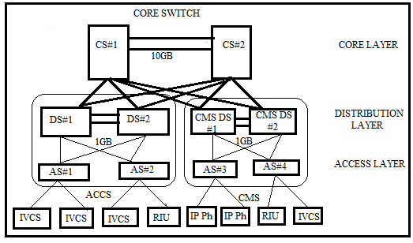
Figure 1:SDN Network Architecture

B. DISTRIBUTION LAYER

The Distribution Layer is positioned between the Core and Access Layer. It distributes network traffic between related access layers and separates the locally destined traffic from the network traffic destined for other layers through the core. It facilitates switching of the traffic between the Ethernet Edge Switches connected to it without bothering the core layer and only allows traffic to enter the core layer if it is required to communicate with another system or equipment out of its domain. Distribution switches are 10 slotchassis based high end Ethernet routing switches that are capable of handling connectivity of a large number of Access switches and their real time traffic needs.

C. ACCESS LAYER

The Access Layer is the outer most layer of the network and provides connectivity to end equipment as required. The access layer consists of a multitude of standalone Ethernet Edge Switch-24Port andGate way units.
In ACCS and CMS Sub network these devices are connected to respective Distribution Switches and In Core layer these devices are connected to Core Switch. Five numbers of Switches are used for ACCS, Six number of switches are used for CMS. Four numbers of Gate units and Three number of switches are used for connecting other Ship systems with IP Interface. The end equipments can be IP Phones, Integrated Versatile Communication System(IVCS), Personnel Computer(PC), Radio Interface Unit(RIU).

IV. PROPOSED ALGORITHM

In a PIM-SM domain, shared trees and shortest the f irst packet of data from sources across a shared tree. A shared tree consists of a set of paths that connect all members of a multicast group to the RP. PIM creates a shared tree when sources and receivers send messages toward the RP.

In shortest path tree algorithm, after receiving a certain number of packets from the RP, the DR switches from a shared tree to a shortest-path tree (SPT). Switching to an SPT creates a direct route between the receiver and the source[10]. The Ethernet Routing Switch switches to the SPT after it receives the first packet from the RP. The following steps describe how a receiver joins a multicast group:
1. A receiver multicasts an IGMP host membership message to the group that it wants to join.
2. After the last-hop router (the DR), which is normally the PIM router with the highest IP address for that VLAN, receives the IGMP message for a new group join, the router looks up the associated elected RP with responsibility for the group.

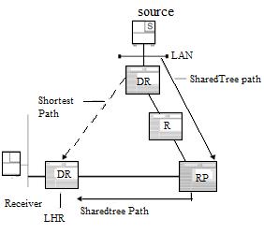
Figure 2:Shared Tree and SPT.

3. After it determines the RP router for the group, the last-hop router creates a (*,G) route entry in the multicast forwarding table and sends a (*,G) join message to the RP. After the last-hop router receives data packets from the RP, if the multicast packet arrival rate exceeds the DR threshold, the last-hop router switches to the IP multicast fundamentals SPT by sending an (S,G) join message to the source. (S denotes the source unicast IP address, and G denotes the multicast group address.)
4. If the switch to the SPT occurs, all intermediate PIM routers along the path to the source create the (S,G)entry. To trim the shared tree, the router sends an (S,G) prune message to the RP.[11]
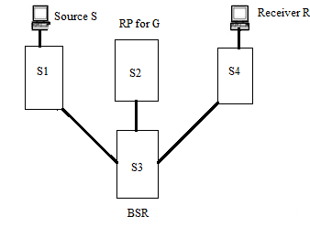
Figure 3: PIM-SM Simplified Example

In the sample configuration, the following events occur:
1. The BSR distributes RP information to all switches in the network.[12]
2. R sends an IGMP membership report to S4.
3. Acting on this report, S4 sends (*,G) join message to RP.
4. S sends data to G.
5. The DR (S1 in this example) encapsulates the data that it unicasts to RP (S2) in register messages.
6. S2 decapsulates the data, which it forwards to S4.
7. S4 forwards the data to R.
8. If the packet rate exceeds the DR threshold, S4 sends S1 an (S,G) join message.
9. S1 forwards data to S4. After S4 receives data from S1, it prunes the stream from the RP.

V.SIMULATION RESULTS

The simulator used here is the OPNET modeler. Simulation models for IGMP, PIM SM and support tools were constructed using the OPNET [14] simulation platform. Opnet Modeler provides environment for building protocols and device models.An environment to plan changes by illustrating how the networked environment will perform. An environment that includes hundreds of pre-built models, used to study performance changes of the network: organizational scaling, technology changes and application deployment.
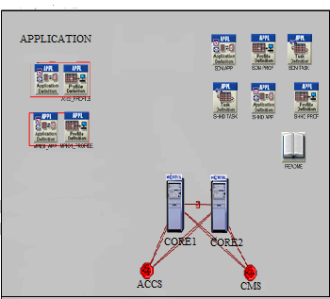
Figure 4: Network Diagram of SDN
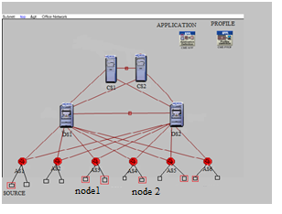
Figure 5:Network Diagram of ACCS Network
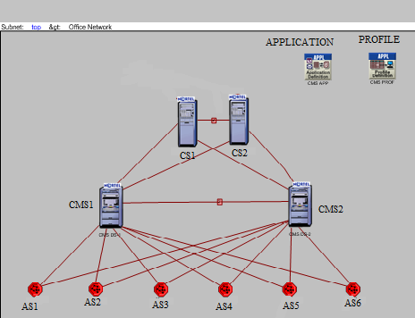
Figure 6:Network Diagram of CMS Network

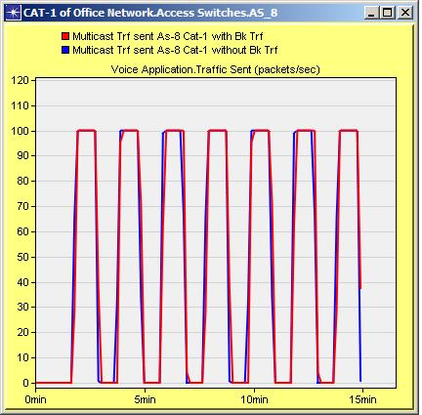
Figure 7: Multicast Traffic Sent

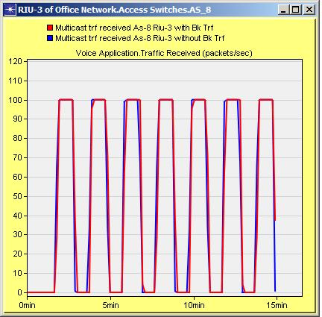
Figure 8: Multicast Traffic received at node1

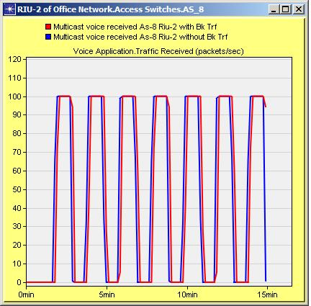
Figure 8: Multicast Traffic received at node2
The objective of simulator is to perform modelling and simulation of SDN network using OPNET simulation, the following approach hasbeen adapted: Create Topology, Model various source and sink equipments, Link Bandwidth, Create Traffic. The network diagram of SDN,ACCS and CMS network which are created by the simulator are shown in figure 4,5 and 6 respectively.

Voice application is created to initiate multicast voice call and holds for 1 minute duration and call repeats for every 2 minutes duration. The voice traffic sent is same with or without background traffic, therefore there is no voice traffic dropped with background traffic loaded as shown in the above Figure 7. The multicast voice traffic received on both the IP nodes are same with or without background traffic, therefore there is no voice traffic dropped with background traffic loaded as shown in the Figure 8 and 9. All multicast calls are successfully received by the IP node.Figure 10 shows that there exists a negligible jitter.

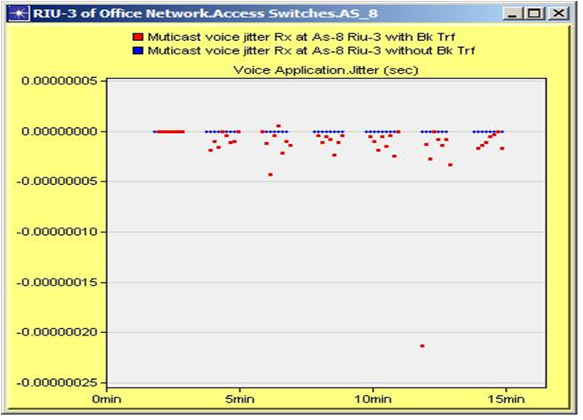
Figure 10: Jitter of the voice application

VI CONCLUSION

The simulation result of the OPNET modeler shows that the traffic sent by the source is 100packets/sec and the traffic received by the multicast group receivers are 100packets/sec. It can be concluded that, the amount of traffic which is sent at the source will be received by the multicast group receivers of the SDN network. As future work, we plan to integrate different multicast and QOS testing for the SDN network with Spirent Test Centre and Spirent36.

ACKNOWLEDGEMENT

We would like to thank Mr. Deepak, Development and Engineering, Bharath Electronics Limited [BEL] and Reva Institute of Technology and Management [RITM].

REFERENCES
- S.E.Deering, “Multicast Routing in Internetworks and Extended LANs,” Stanford University, Stanford, CA, USA, 1988
- Youssef Baddi, Mohamed Dafir Ech-Cherif El Kettani,”QoS-VNS-CS: QoS constraints Core Selection Algorithm based on Variable Neighbourhood Search Algorithm”, International Journal of Communication Networks and Information Security (IJCNIS), April 2014.
- “PIM-SM router operation and types”,http:/www.pim sm multicast/msdn.com
- D Estri, D Farinacci, PIM-SM: Protocol Specification, RFC 2362, June 2000.
- Baddi and E.L.Kettani, “VNS-RP algorithm for RP selection in multicast routing protocol PIM-SM ”,International Conference on Multimedia Computing and Systems (ICMCS) ,595-600,May 2012.
- Mohammed V, “Minimizing Cost and Delay in a Shared Multicast Tree ”.
- Youssef Baddi, Mohamed Dafir Ech-Cherif El Kettani, “Parallel GRASP Algorithm with Delay and Delay variation for RP selection in PIM-SM multicast routing”, Journal of Theoretical and Applied Information Technology, vol.57 ,2003.
- Ahmed Helmy,Deborah Estrin and Sandeep Gupta, “Fault Oriented Test Generation for Multicast Routing Protocol Design”USC-CS-TR,598 673,1998.
- Parkhurst, “Cisco Multicast Routing and Switching”,MCGraw Hill, 1999
- Bartzack ,P Zwirzeikowaski “Ip Multicast Technologia Przyszłości” Networld, pp. 65-68,June 2007
- D Kosiur, “IP Multicasting:The complete giuide Interactive corporate Networks”Willey Computer Publishers 2002.
- N.Bhaskar, A Gal,J Lingard, S Venaas, “ BootStrapRouter Mechanism for PIM ” ,IETF RFC 5059,Jan 2008
- Todor Blaga, Virgil Dobrota, Daniel Zinca, Gabriel Lazar,”Multicast Routing in IPV4/IPV6 using Linux and Free BSD”, 2004
- Mil3 Inc., “OPNET Reference Materials”, http://www.mil3.com
- Xin wang,Paul Strik “IP Multicast Fault Recovery in PIM over OSPF”,Dept of CS Columbia University”

